Vera Obolensky with Yuri aged 8 (1928)

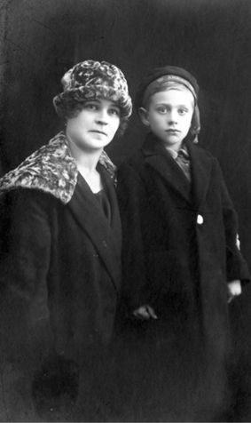

(From Forever Russian by “Georges” Yuri Obolensky)

